11ac 900Mbps Outdoor CPE

Model: GNT-CP530

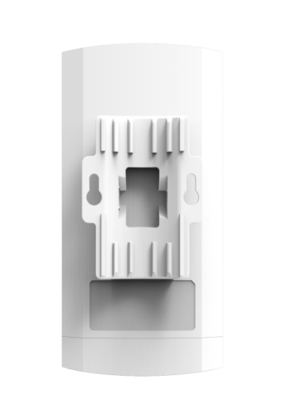

Description:

GNT-CP530 is an economic 11ac outdoor CPE with 900Mbps data rate. Comply with IEEE 802.11b/g/n/ac standard, with 12dBi dual polarized high gain antenna, the PTP/PTMP distance is more than 2000 meters.

It support Wireless AP, Wireless Bridge operation mode for PTP/PTMP connections, with slid switch on device, easy to set GNT-CP530’s operation mode, no need to access into GUI, avoid the complex setup program; With LED display, simple to set the IP address, channel and view the connected status and signal strength, save much human work and cost, make the long range wireless coverage, data transmit and wireless monitoring simple and professional.

GNT-CP530 with ABS waterproof, dustproof and sunscreen shell, temperature adaptive also; Meantime, it support 24V passive PoE, ESD protection and surge protection, ideal for outdoor use;

Most Important, GNT-CP530 support watchdog self-detection function, reboot and recover device automatically if some network attack. Besides that, it support cloud remote management and software AC controller, administrator can monitor the working status, upgrade firmware, reboot, timed reboot device through cloud server, recover and maintain device at any time and any location, operator level outdoor PTP/PTMP connection equipment.

Specification:
Hardware:
Chipset | Media Tek: MT7628DAN+MT7613AE
DDR2 | 64MB
Flash | 8MB
Wireless | IEEE 802.11 a / n /ac, 2T2R 900M MIMO Technology
Frequency | 5.150GHz～5.850GHz
Data Rate | 900Mbps
WAN | 1 * 10/100Mbps RJ45 WAN Port
LAN | 1 * 10/100Mbps RJ45 LAN Port
Buttons | 1 * Slid Switch to change the operation mode, H mean host, AP mode; C mean client, Repeater mode
Buttons | 1 * LED display with F(function) and S(select) buttons, show and set operation mode, channel, IP address, signal strength.
Buttons | 1 * Reset Button, press 1 second, work with slid switch to change the operation mode;  Press 10 seconds, the device will revert to factory default settings.
Antenna | 12dBi Panel Antenna
RF Power | ≤ 21dBm
PoE Power | POE 24V/0.5A
Power consumption | < 8W
Waterproof Level | IP65
ESD Protection Standard | Contact Discharge: ±6KV; Air Discharge: ±8KV
Surge Protection Standard | Common mode:±2KV; Differential mode:±1KV (Optional: Common mode:±4KV; Differential mode:±2KV)
LED Light | Sys(System), WAN, LAN, Wi-Fi
Size | 168mm*88mm*57.6mm
Working Temperature | -30°C ~ 55°C
Storage Temperature | -40°C ~ 70°C
Humidity | 5% ~ 95% (Non-condensing)
Firmware
Operation Mode | Wireless AP, Wireless Bridge
 | IEEE 802.3(Ethernet)
Protocol/Standard | IEEE 802.3u(Fast Ethernet)
 | IEEE 802.11b/g/n/ac(5.8G WLAN)
Other Features | SSID: up to 4
 | Support SSID hide

Other Features | Wireless security: OPEN、WPA、WPA2、WPA-PSK、WPA2-PSK
Other Features | Wireless MAC filter: support white list(32)
Other Features | Wi-Fi timed off/on
Other Features | User isolation: wireless network isolation, AP insolation
Other Features | RF power adjustable
Other Features | Support Watchdog Technology
Other Features | With Wi-Fi Channel Analysis Tool
Other Features | Central Managed by WLAN Controller in AP Mode  Remote Managed by Cloud Server in AP and Repeater Mode
Device Management | Backup the configuration information
Device Management | Restore the configuration information
Device Management | Revert to factory default
Device Management | Restart: Immediately restart or timed restart
Device Management | Firmware upgrade
Device Management | Time management: system time management and synchronization time.
Device Management | System Log

Package:
GNT-CP530M unit
24V/0.5A PoE Adapter
User Manual
LAN Cable

Product Structure:
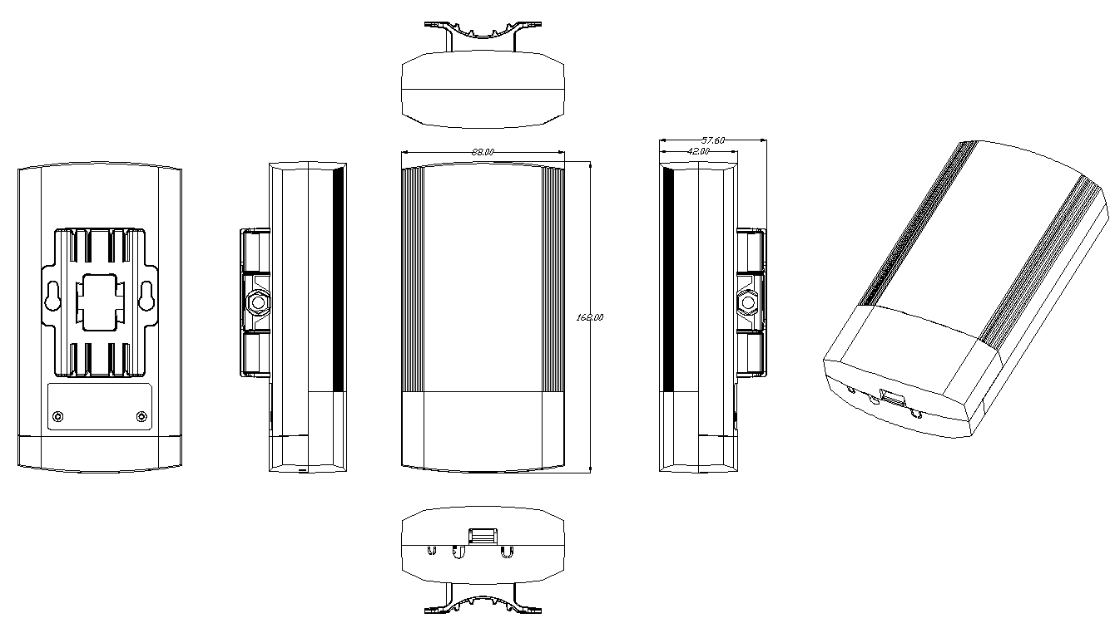

Product Sticker:
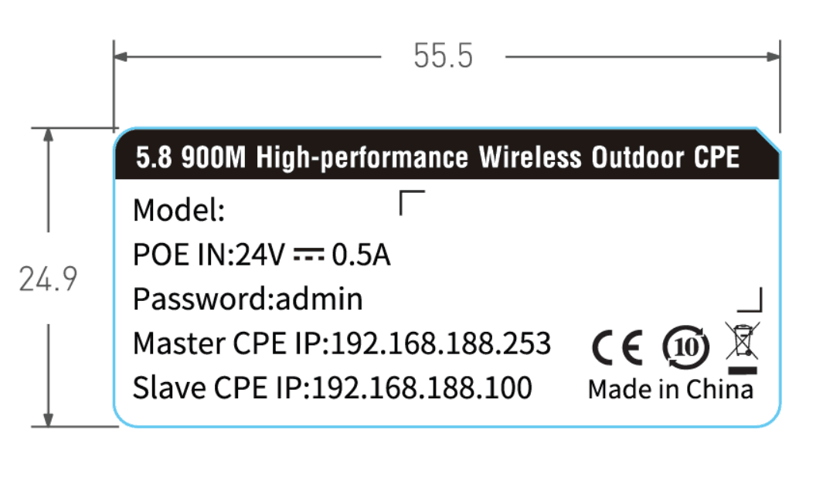

Packing Box:
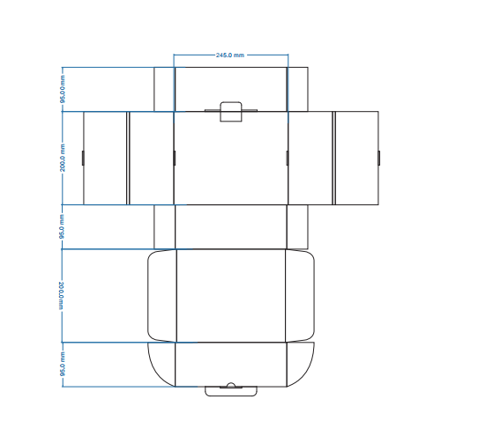

Carton box picture:
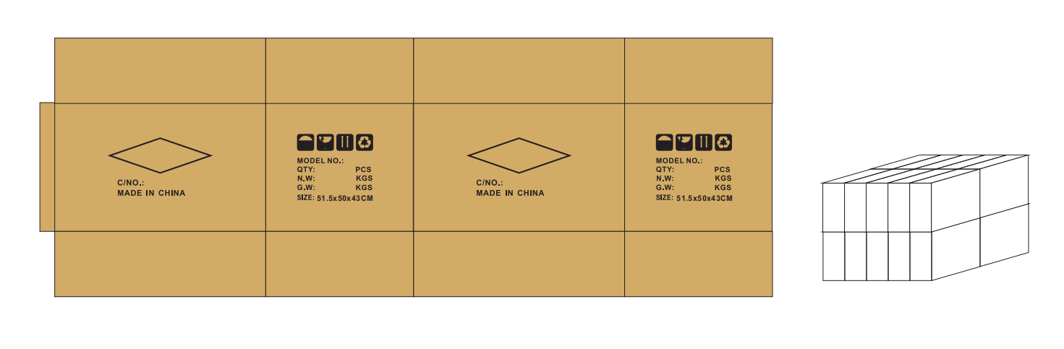
Working Diagram:
Point to Point connection:
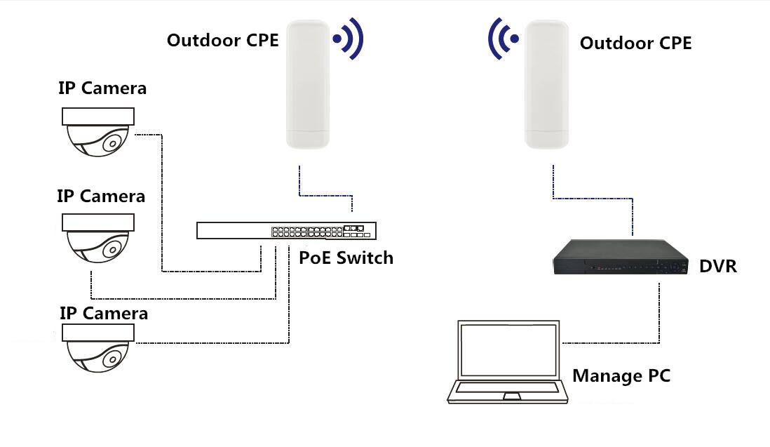
Point to Multi-Point connection:
